**Step 1 :** **click on configure**

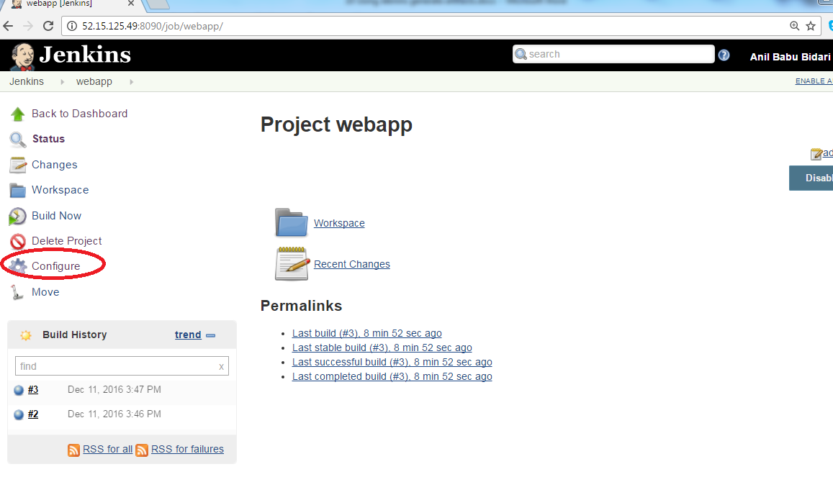

**Next step :** **click on Post-build-actions**

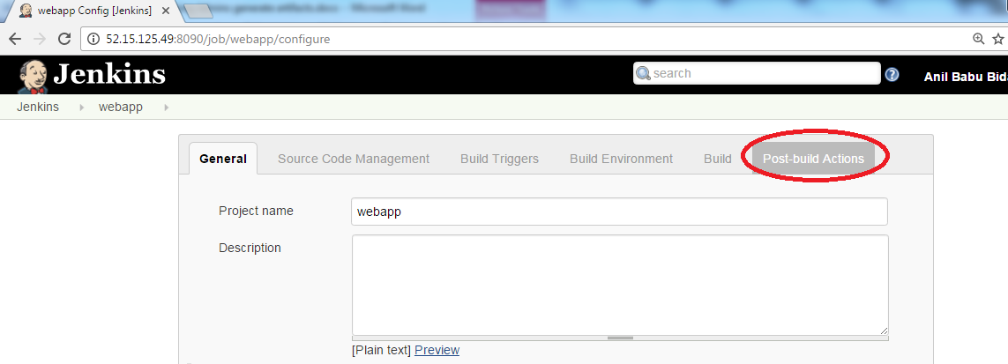

**Next step :** **click on Add Post-build-actions**

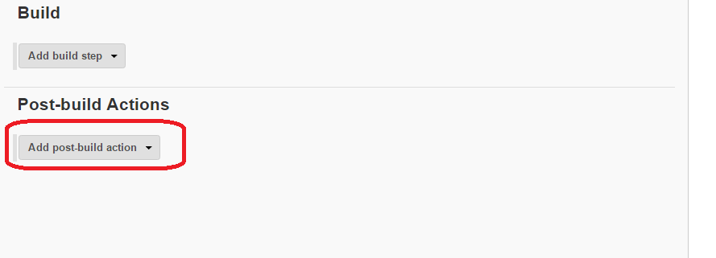

**Next step :** **Choose Archive the Artifacts**

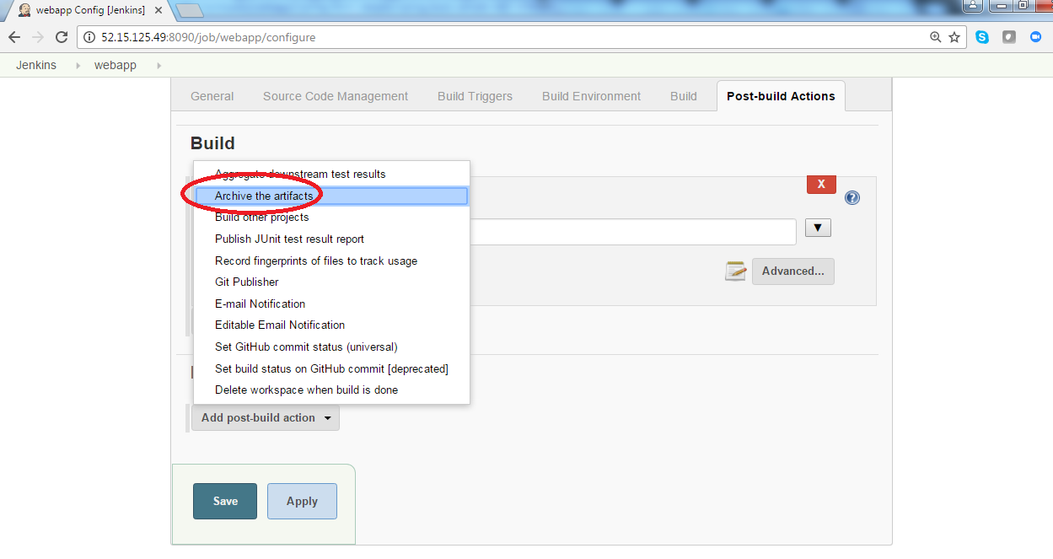

Note :  **Artifacts** can be used to represent data created as a side-effect of running a **Jenkins** build. **Artifacts** are files which are associated with a single build. A build can have any number of **artifacts** associated with it.

**Next step :** **Provide the below path and click save**

spring-boot-samples/spring-boot-sample-web-static/target/*.jar

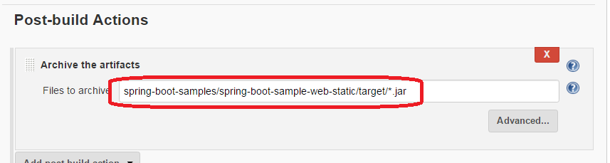

**Next step :** **Click Build now**

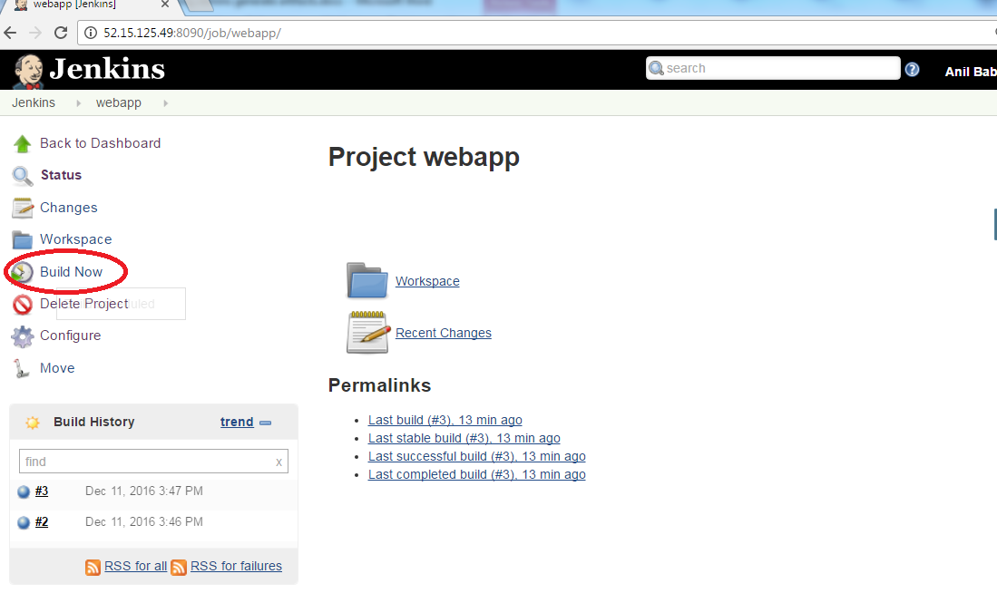

**Next step :** **Click on your build name**

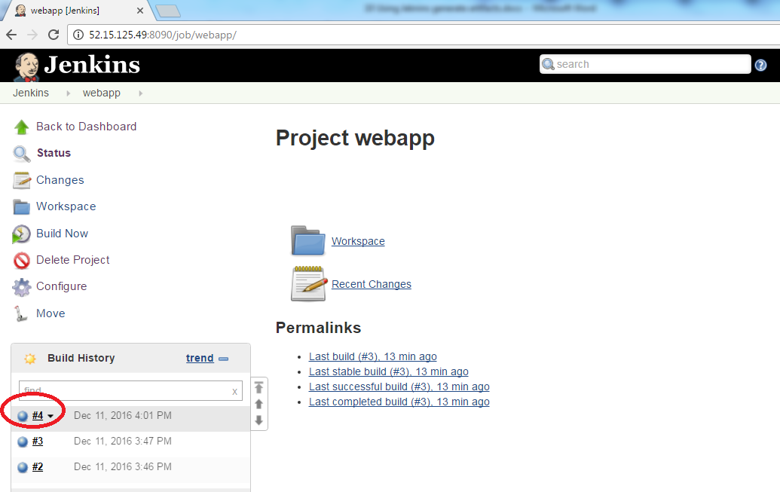

**Next step :** **You should see your jar file**

